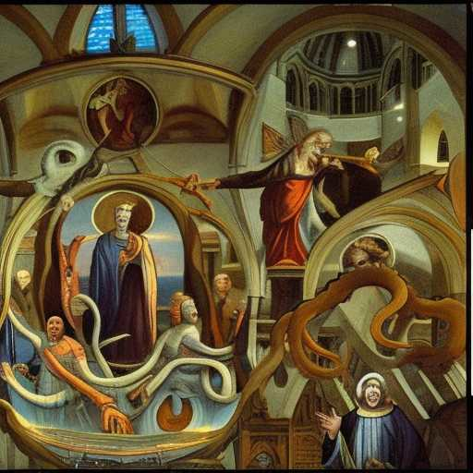
THE MERCHANTS OF PISCES

The Merchants of Pisces are coalescing around the Church of Economy

The tentacles of this church extend
through the Vatican, London, Davos & D.C.

Philosophical materialists are attering themselves with priestly presumption

